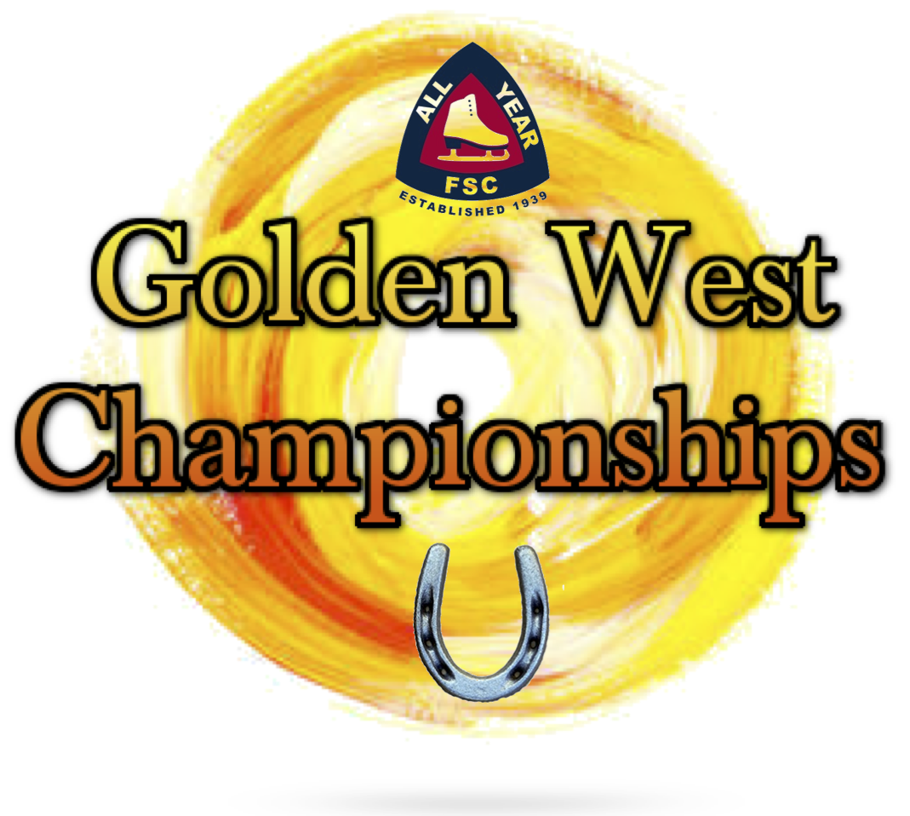

August 30 - September 1, 2024
COMPETITION FOR SINGLES and PAIRS
Hosted by:
All Year Figure Skating Club
Sanctioned by U.S. Figure Skating
Entry Deadline: August 5, 2024
(or earlier if maximum capacity is reached)
Great Park Ice, Irvine
888 Ridge Valley
Irvine, CA 92618
(949) 774-1600

 | 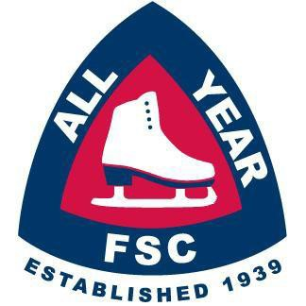 |  | 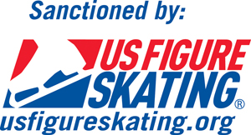

Competition Information
Welcome to the 2024 Golden West Championships
I. COMPETITION OVERVIEW

The Golden West Championships will be conducted in accordance with the rules and regulations of U.S. Figure Skating, as set forth in the current rulebook, and/or current Compete USA handbook as well as any pertinent updates that have been posted on the U.S. Figure Skating website

This competition is open to all eligible, restricted, reinstated, or readmitted persons as defined by the Eligibility Rules. Skaters must be a currently registered member of a U.S. Figure Skating club, Learn to Skate USA member, a collegiate club or who is an individual member in accordance with the current rulebook. For non-U.S. citizens, please refer to the rulebook for more information.

SERIES INFORMATION:
This event is part of the Southern California Inter-Club Invitational Series. Top point scorers, at the end of the season, will be invited to the Invitational Final. Please see the Southern California Inter-Club Association website at https://www.socalinterclub.org/scica-invitational-series for more information.

II. ELIGIBILITY

Singles: Excel and Well-Balanced Events:
- Skaters must meet at least the minimum singles test requirements for the event’s level. A skater’s singles test level may be higher than the minimum requirement.
  - Skate Up is allowed: skaters may skate up one level higher than their minimum test requirement allows.
- Skaters may not register for an event level lower than allowed by their competitive floor. An athlete’s competitive floor is set by one of the following scenarios:
  - If an athlete has a paid EMS series application for the NQS series, the event level registered for in the most recent NQS will become the lowest level they may compete at in any U.S. Figure Skating sanctioned event.
  - If an athlete has a paid EMS series application for the Excel Series, the event level registered for in the most recent Excel series will become the lowest level they may compete in any Excel event. For Well-Balanced and Specialty events the skater will be permitted to register at one level lower than the “floor” set by their excel series entry.
  - If an athlete has never had a paid EMS series application in the NQS or Excel series, the athlete may select their level based on their goals and technical skills as long as the minimum test requirements are met.
- Skaters are not permitted to enter an Excel free skate and a Well-Balanced free skate event at the same competition (example: Juvenile Girls Free Skate and Juvenile Girls Excel Free Skate). However, they are permitted to enter an Excel and a Well-Balanced event of different types such as a short program (if stand-alone event option), specialty or showcase events (example: Intermediate Women Short Program and Intermediate Women Excel Free Skate).
- For more details about establishing event levels, refer to information sheet HERE or email events@usfigureskating.org.

All other Adult Singles and Well-Balanced Pair events
- Skaters must meet the minimum test requirements for the events level, but not exceed the maximum permissible test requirement.

EVENTS OFFERED:
Program requirements for the events listed below can be found here: usfigureskating.org – Skate – Compete – Program Requirements
This event will follow program requirements for the 2024/2025 competition season. Please be sure to check all rules and Technical Notifications from U.S. Figure Skating for any changes or updates. U.S. Figure Skating and All Year FSC are deeply vested in the health and safety of all competitors at our events. In order to provide professional medical emergency services, the below fees include a $10 medical surcharge on the 1st event.
SINGLES | JUDGING | 1st Event Price | 2nd Event Price
Excel Free Skate (Preliminary Plus – Senior) | IJS | $155 | $95
Well Balanced Short Program (Juvenile – Senior) | IJS | $155 | $95
Well Balanced Free Skate (Pre-Preliminary – Senior) | IJS | $155 | $95
Adult Free Skate (Adult Pre-Bronze – Master Jr/Sr) | IJS | $155 | $95
Adult Beginner & High Beginner Free Skate | 6.0 | $120 | $80
PAIRS | JUDGING | 1st Event Price | 2nd Event Price
Short Program | IJS | $200 | $110
Free Skate | IJS | $200 | $110
SHOWCASE | JUDGING | 1st Event Price | 2nd Event Price
Emotional Performance (Pre-Preliminary – Senior) | CJS | $135 | $75
Choreographic Artistry (Juvenile - Senior) | CJS | $135 | $75
Lyrical Pop (Pre-Preliminary - Senior) | CJS | $135 | $75
Character Performance (Pre-Preliminary - Senior) | CJS | $135 | $75
Comedic Impressions (Pre-Preliminary - Senior) | CJS | $135 | $75
Adaptive Individual Showcase | CJS | $125 | $75
COMPETE USA EVENTS | JUDGING | 1st Event Price | 2nd Event Price
Snowplow Sam-Basic 6 Program w/ Music | 6.0 | $115 | $75
Snowplow Sam Showcase events (Lyrical Pop and Character Performance) | 6.0 | $115 | $75
Basic 1-6, Aspire 1-4 Showcase events (Emotional Performance, Character Performance, Lyrical Pop) | 6.0 | $115 | $75
Aspire 1-4 Program w/ Music | 6.0 | $115 | $75
Excel Free Skate (Pre-Preliminary - Preliminary) | 6.0 | $115 | $75

OUR COMMUNITY:
U.S. Figure Skating is dedicated to fostering a culture of belonging and community that is welcoming for all individuals. We are committed to championing diversity, equity and inclusion and understand its value in combating discrimination and challenging inequalities necessary to develop champions both on and off the ice. We are actively working toward developing equitable practices and policies that foster safety and empower all individuals to authentically pursue their unique path in all areas of our sport. We stand firmly on the belief that our members are the most important asset to our organization and that our differences are meaningful and strengthen our sport. We believe that skating is for everyone.

NON-DISCRIMINATION:
U.S. Figure Skating commits in policy, principle and practice to sustain a non-discriminatory approach on and off the ice for all members. We strive to provide equal opportunity for all despite their varied backgrounds, experiences and identities, and want all members to feel valued and respected at every level of organization. U.S. Figure Skating’s SkateSafe® Program receives, investigates and addresses allegations of discrimination or harassment throughout its membership and the organization. Please refer to the SkateSafe® Program Handbook for further definition of harassment, discrimination and abuse.

By attending this event, all participants are willingly committing to upholding U.S. Figure Skating’s Code of Ethics (GR 1.01) and Code of Conduct (GR 1.02), as detailed within the U.S. Figure Skating Rulebook.

To report a concern of discrimination or harassment to U.S. Figure Skating, please visit www.USFigureSkating.org/SkateSafe or email SkateSafe@USFigureSkating.org.

COMPLIANCE:
U.S. Figure Skating and All Year FSC strive to provide a safe environment for its members that is free of misconduct and harassment. For full details about participant compliance requirements, refer to the U.S. Figure Skating SkateSafe® webpage: https://www.usfigureskating.org/skatesafe#compliance.

COACHES:
To be an eligible coach at a nonqualifying competition, coaches must meet the applicable compliance requirements and verified by U.S. Figure Skating. Coach compliance falls into two categories, Coach Compliance (includes choreographers) and Learn to Skate USA® Instructor Compliance. Details regarding compliance requirements can be found HERE. All compliance requirements must be met at the time of check-in to access the competition, no exceptions.
Coaches of foreign athletes: If you are a coach of a foreign athlete only, you are not subject to U.S. Figure Skating coach compliance and will only be asked to provide a letter of good standing for the federation your athlete represents.
Coaches Credentials will be provided as follows:
- One coach per skater will receive a credential at no charge
- One additional coach credential per skater may be purchased for $10 (credential must be requested during entry process on EMS). Can be purchased online only no later than May 24, 2024.
With EMS, coaches must be included within a skater/team’s registration or updated through their EMS Skater Portal via “My Coaches” or “Team Personnel.” All coaches declared at the time of registration will be included on the registration confirmation email. Note: There is no registration approval process within EMS as the data (membership and test level) is tied to the U.S. Figure Skating database. Non-compliant coaches will receive automated email reminders through the start of the competition.
EMS Coach Resources (not SYS or TOI):
- My Competitions
- My Skaters
- Coach Schedule

PAIRS - MANDATORY ATHLETES:
Athletes age 18+ as of the competition start date who will be competing on a team (i.e., synchro, ice dance, pairs, shadow dance, theatre, etc.) with at least one Minor Athlete must complete SafeSport™ Training. *
Minor athletes who turn 18 mid-season are encouraged to seek parental consent to take the online SafeSport™ Training early to avoid any disruptions in their ability to participate as the training is required upon turning 18. The athlete will not be compliant until they have completed the training and their Members Only portal reflects completion. Please email skatesafe@usfigureskating.org for instructions or questions regarding parental consent.
III. REGISTRATION INFORMATION

ONLINE REGISTRATION VIA EMS:
Online registrations will be accepted via EMS. Payment must be made at the time of registration by credit card only. Each transaction includes a 3% transaction fee.

Registration Deadline: 08/05/2024 at 11:59 PM ET or earlier if maxium capacity is reached.
Late Registration Deadline: 08/08/2024 at 11:59 PM ET + $50 Late Fee
*All Year FSC reserves the right to close registration at any time if event capacity is reached. In the event of early closure, a “wait list” will be created by informing the event Chair and Registrar that you wish to be added to the “wait list”. Being added to the “wait list” does not guarantee entry to the event.

- Go to www.usfsaonline.org
- Enter your U.S. Figure Skating or if Compete USA events are offered, your Learn to Skate USA® member number and password
  - If you need assistance with your member number and password, contact Member Services at memberservices@usfigureskating.org.
- Click EMS then “Competition Registration”
- Choose “Golden West Championships” from the list of nonqualifying competitions.
  - If you need assistance completing your registration, contact productsupport@usfigureskating.org.

PARTNERED EVENTS:
Only one partner will complete registration for the team. During the registration process, you will be asked to identify your partner and verify their test information. The registered partner will be responsible for managing all aspects of the competition for the team including music/PPC upload, practice ice sales, etc.

FOREIGN SKATERS:
Non-U.S. skaters intending to register for this competition must set up a non-member account prior to registering for the competition (click here for HOW TO). This can be done by choosing the “Non-Member? Create Account” option on the Members Only login page.
TEST CREDIT:
Skaters entered in an event that would meet the requirements for test credit may request their test credit forms at registration or through EMS. Forms requesting a TEST CREDIT packet must be filled out and submitted through EMS or handed to the Registration Desk along with a $10 fee, prior to the start of their free skate event. Once the event is over, only a skater who achieves a test “pass” will receive the full packet from the accounting room.

MUSIC SUBMISSION/UPLOAD:
EMS MUSIC UPLOAD: Competitors participating in events with music are required to upload their music to EMS no later than August 23, 2024 at 11:59 PM ET. After this date, skaters will be locked out of this feature and subject to a $40 late fee. The late fee will automatically be added to each skater's cart who doesn't meet this requirement by the deadline. Late fees will not be removed under any circumstances and must be paid prior to receiving the skater credential onsite.
DEADLINE: DATE *August 23, 2024 at 11:59 PM ET – Late Fee $40
EMS SKATER MUSIC UPLOAD HOW TO: CLICK HERE

If you need assistance, email productsupport@usfigureskating.org

Competitors must also have available a backup copy of their competition music on a cell phone and it must be immediately available rink side whenever the skater competes. If the phone does not have the standard round headset connector, an appropriate adapter, such as an Apple Lightning connector or Samsung USB-C adapter is required to be attached. The phone should be presented to the music person with the file ready to play, phone in airplane mode and volume turned to maximum.

EMS PLANNED PROGRAM CONTENT (PPC):
Competitors participating in IJS events are required to submit PPC in EMS no later than August 23, 2024, 11:59 PM ET. After this date, skaters will be locked out of this feature in EMS and subject to a $40 late fee. The late fee will automatically be added to each skater’s cart who doesn’t meet this requirement by the deadline. Late fees will not be removed under any circumstances and must be paid prior to receiving the skater credential onsite.
DEADLINE: DATE * August 23, 2024 at 11:59 PM ET – Late Fee $40
EMS PPC UPLOAD HOW TO: CLICK HERE

If you need assistance, email productsupport@usfigureskating.org

REFUND POLICY:
Entry fees will not be refunded after August 8, 2024 unless no competition exists or the event is canceled. There will be no refunds for medical withdrawals. The online processing fees are not refundable. Checks returned for non-sufficient funds and contested credit card charges will be issued a $40 fee. Payment of the fee will be required before the skater is allowed to participate in practice ice or events.

LIABILITY:
U.S. Figure Skating, Learn to Skate USA®, All Year FSC and Great Park Ice accept no responsibility for injury or damage sustained by any participant in this competition. This is in accordance with Rule 1600 of the official U.S. Figure Skating Rulebook.

IV. COMPETITION DETAILS

FACILITIES:
Great Park Ice
888 Ridge Valley, Irvine, CA 92618
Rink 3 – 85’ x 200’ with slightly rounded corners. Rink 4 – 85’’ x 200’ with slightly rounded corners
There is a full-service restaurant (Between the Rinks) located upstairs between Rink 1 and Rink 2.

LOCKER ROOMS AND CHANGING AREAS:
Locker rooms and changing areas will not be available for this competition. All athletes are expected to arrive at the arena ready (costumes, hair, make-up, etc…). Athletes will be provided with an area to put skates on but changing will not be permitted in these spaces.
U.S. FIGURE SKATING TRAVEL POLICY:
All travel must strictly adhere to Two-Deep Leadership requirements. An Adult Participant cannot transport a Minor Athlete one-on-one and Two-Deep Leadership requirements must be adhered to at all times during In-Program travel, by transporting at least two minors or a second Adult Participant. An Adult Participant cannot share a hotel room or other sleeping arrangement with a Minor Athlete(s). Full details of the SkateSafe® Travel Policy and any exceptions can be found starting on page 12 of the SkateSafe® Handbook.
OFFICIAL NOTICES:
An official posting area will be maintained inside the lobby area of the arena.
The official schedule of events will be posted on EMS. It is the responsibility of each competitor, parent and coach to check the the websites listed above frequently for any schedule changes and/or additional information. During the competition, updates will be posted through the on-line portal and will supersede all other schedules. Notices posted on the All Year FSC website will be considered sufficient notice to all skaters. No schedules will be mailed. Skaters are requested to arrive 45 minutes prior to the scheduled time of their event. A tentative schedule of events will be posted as noted above prior to the competition.

RESULTS:
Online results will be utilized for this competition. QR Codes will be posted around the facility as well as provided on athlete and coach credentials.

SCHEDULE:
Competitors may be scheduled on any day or time during the announced dates of the competition. The competition and practice ice schedule will be available after the close of entries. All participants will be notified via email once available.

PRACTICE ICE:
Depending on the number of applicants, practice ice for the competition may be offered. If offered, final details for scheduling practice ice will be made available to competitors through EMS. Any practice sessions will be considered to be Unofficial Practice Ice (UPI) and no music will be played.

ATHLETE FEEDBACK SESSIONS:
Depending on total number of entries and availability of ice time, All Year FSC may be hosting “Athlete Feedback Sessions”. These sessions will consist of a Judge and Technical Panel member who will provide “on-ice” feedback to skaters from singles and pairs Juvenile through Senior levels. If time is available, a notice will be sent out to all eligible athletes and a sign-up process will be incorporated.

ONSITE CHECK-IN:
Check-in will open on Friday, August 30 or Saturday, August 31 at approximately 7am. On-Site Check in through EMS will be used at the Registration desk which will be located in the Lobby area between Rink 3 and Rink 4

AWARDS:
Awards will be presented for the first four placed skaters in each event level/group. There will be no Final Rounds at this event. All competitors in Short Program or Free Skate events will be eligible for the 2024 Golden West Achievement Award to be presented at the completion of the competition. The Ronald O. Nichols Memorial Trophy will be presented to the Golden West Juvenile Woman with the highest Total Score. The Les Seale Memorial Trophy will be awarded to the Golden West Intermediate Woman with the highest combined Short Program and Free Skate score.
PHOTO/VIDEO:
Coronado Video (http://coronadoproductions.tripod.com) will be the official videographer. A professional photographer (http://cynthiaslawterphotography.com) for award and action photographs will be at the rink. All other videotaping and photography is restricted to hand-held battery operated equipment, without tripod. No photography or videotaping, except by the official photographer, without the express permission of the person being photographed or videotaped is allowed.
Solicitation by any photographer, or agent, of anyone to be the subject of still or video photography is not permitted. NO FLASH PHOTOGRAPHY DURING THE EVENTS IS ALLOWED.
OFFICIAL HOTEL:
The Official Hotel for the 2024 All Year Open is the DoubleTree by Hilton Hotel Irvine-Spectrum. A Group rate of $169 per night has been negotiated. Please follow the link to make your reservation. To make a reservation, please click this link GOLDEN WEST CHAMPIONSHIP (hilton.com) The special group rate is available until August 09, 2024. If you choose to dial the hotel directly (949-471-8888), please reference Golden West Championships to secure the group rate.

CONTACT INFORMATION:
For questions, please contact the following individuals:
Competition Chair: | Marina Nash | Marina.Nash@gmail.com
Competition Co-Chair: | Kerry Novick | knovick@henson.com
Chief Referee | Stefanie Mathewson | smathewson@me.com
Registrar: | Helene Krasner | hjkrasner@gmail.com or 424-374-8104
Additional Contact: | Doug Williams | glidnby@yahoo.com

