2026 ORANGE TWIST OPEN
Saturday, March 28, 2026

Center Ice Arena
201 S. Plum Ave, Ontario, CA 91761
www. https://www.ontariocenterice.com/

Hosted by All Year Figure Skating Clubhttps://www.ontariocenterice.com/ Sanctioned by U.S. Figure Skating

Entries are accepted online only at www.EntryEeze.com

For more information, please contact the competition chair, Tony Serhal.
tony@tmsrestoration.com

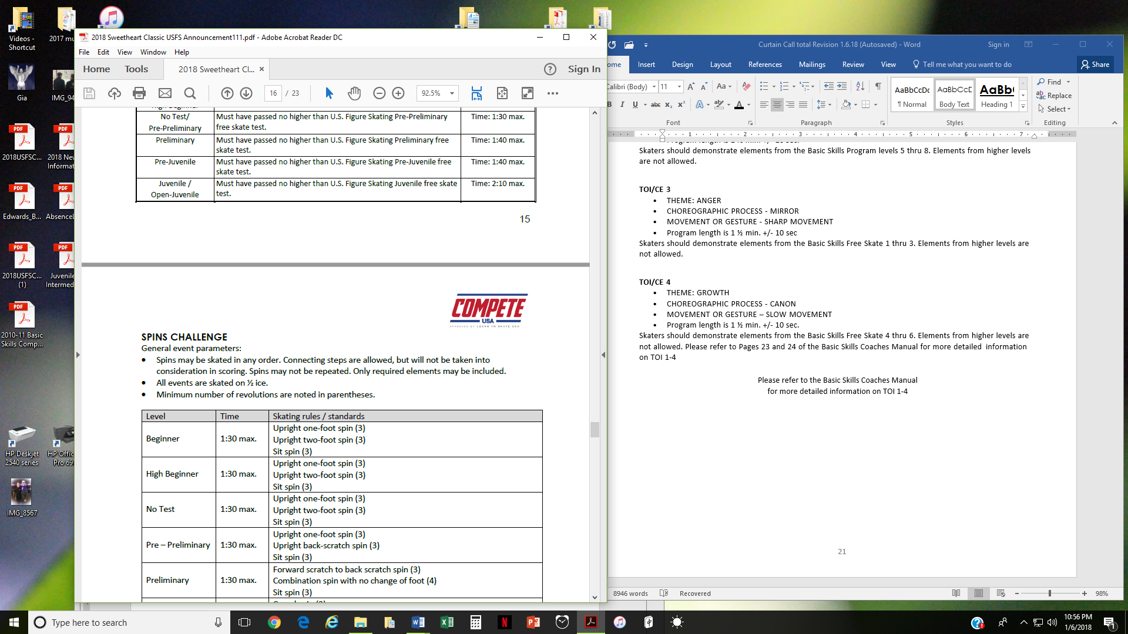 | 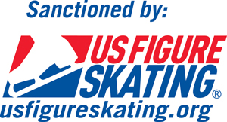

Competition Information
Welcome to the 2026 Orange Twist Open Competition.
I. COMPETITION OVERVIEW
The 2026 Orange Twist Open Competition will be conducted in accordance with the rules and regulations of U.S. Figure Skating, as set forth in the current Compete USA handbook as well as any pertinent updates that have been posted on the U.S. Figure Skating website.

This competition is open to all eligible, restricted, reinstated or readmitted persons as defined by the Eligibility Rules. Skaters must be a currently registered member of a U.S. Figure Skating club, Learn to Skate USA member, a collegiate club or individual member in accordance with the current rulebook. For non-U.S. citizens, please refer to the rulebook for more information.

SERIES INFORMATION:
This event is part of the Southern California Inter-Club Invitational Series. Top point scorers, at the end of the season, will be invited to the Invitational Final. Please see the Southern California Inter-Club Association website at https://www.socalinterclub.org/scica-invitational-series for more information.

II. ELIGIBILITY
AGE RESTRICTIONS/ELIGIBILITY/TEST LEVEL:
All competitors must be eligible persons and members in good standing of Learn to Skate USA or U.S. Figure Skating (including Aspire) by the close of entries. Qualifying tests and ages for all events are as of close of entries Sunday, March 1, 2026.
All levels may skate one level higher than that for which they are qualified but may not skate more than one level in each discipline, except as specifically noted below. Age restrictions apply as follows:
Age Requirements/Restrictions – Singles Discipline (ALL ages are as of March 28, 2026):
Skaters entering beginner through preliminary events will be divided as closely as possible by age at the discretion of the referee. If necessary, the referee will combine events as needed based on entries.
ELIGIBILITY RULES FOR “Learn to skate USA” / “Compete USA” PARTICIPANTS:
The competition is open to ALL skaters who are current eligible (ER 1.00) members of either the Learn to Skate USA Program and/or are full members of U.S. Figure Skating. To be eligible, skaters must have submitted a membership application or be a member in good standing. Members of other organizations are eligible to compete but must be registered with a Learn to Skate USA Program or member club.
It is very important to the success of the competition that skaters are placed in the correct divisions. If, for whatever reason, the Local Organizing Committee discovers that a skater has been placed in a category that is below their class level, the referee will have the option to move the skater into the proper division, even if this has to be done the day of the competition. This will ensure that every event is as fair as possible to the competitors. It is an ethical violation for coaches to sandbag an event.

Eligibility will be based on skill level as of closing date of entries. All Snowplow Sam and Basic Skills 1-6 skaters must skate at highest level passed or one level higher and NO official U.S. Figure Skating tests may have been passed, including Skating Skills or individual pattern dances.
For the Aspire 1-4 Free Skate, Excel, Well Balanced, and Adult levels, eligibility will be based only upon highest free skate test level passed. Skating Skills test level will not determine skater’s competitive level. Skaters may skate at highest level passed OR one level higher, but not both levels in the same event during the same competition. Skaters may not compete at more than one level in the same discipline type event at the same competition.

EVENTS OFFERED:
Program requirements for the events listed below can be found here: usfigureskating.org --> Skate --> Compete --> Program Requirements. For Compete USA events, please visit: https://learntoskateusa.com/CompeteUSA
- Skating Accommodation Memorandum (S.A.M.): Skaters using a S.A.M. must submit their S.A.M. to the competition chair via email at tony@tmsrestoration.com
  - Click here for more information about S.A.Ms.

NOTE: Skaters may not enter Excel and Well-Balanced free skate events at the same competition.
COMPETE USA EVENTS | JUDGING | 1st Event Price | 2nd Event Price
Snowplow Sam, Basic 1-6 Program w/ Music | 6.0 | $75.00 | $50.00
Aspire 1-4 Free Skate Program w/ Music | 6.0 | $75.00 | $50.00
Excel Free Skate (Pre-Preliminary – Preliminary Plus) | 6.0 | $85.00 | $60.00
Pre-Preliminary – Preliminary Free Skate | 6.0 | $85.00 | $60.00
Adult 1-6 Program w/ Music | 6.0 | $75.00 | $50.00
Adult Free Skate (Beginner – Bronze) | 6.0 | $85.00 | $60.00
Compete USA – Spin Challenge 1-4 | 6.0 | $75.00 | $50.00
Compete USA – Jumps Challenge 1-4 | 6.0 | $75.00 | $50.00
Compete USA - Theatre On Ice | 6.0 | $125.00 | n/a
SHOWCASE | JUDGING | 1st Event Price | 2nd Event Price
Emotional Performance | 6.0 | $75.00 | $50.00
Character Performance | 6.0 | $75.00 | $50.00
Lyrical Pop | 6.0 | $75.00 | $50.00
Comedic Impression | 6.0 | $75.00 | $50.00

III REGISTRATION INFORMATION:
ONLINE REGISTRATION VIA EntryEeze:
Online registrations will be accepted via EntryEeze only. Payment must be made at the time of registration by credit card only.
Registration Deadline: 03/01/2026 at 11:59 pm
Late Registration Deadline: 03/06/2026 at 11:59 pm + $50 Late Fee
Event Change Fee (after Deadline): $15 per event

Entries must be submitted online via EntryEeze by 11:59pm on March 1, 2026. Processing fees are not refundable, even if the event is canceled or skater withdraws before close of entries. If you have any problems, please contact Helene Krasner (Registrar) for assistance. Credit Card Disputes: All Year FSC reserves the right to charge an additional fee of $50.00, in addition to the entry fee to resolve any disputes to the credit card charge.

COMBINATION OF GENDERS: In the following events, both genders may be combined in the same event at the discretion of the referee: All Learn to Skate (Basic Skills and Aspire Free Skate) events; Adult Bronze and below Free Skating events; and Pre-Preliminary through Preliminary Free Skating events, where only one skater has entered their single gender event and has agreed to skate in the combined gender event.

OUR COMMUNITY:
U.S. Figure Skating is dedicated to fostering a culture of belonging and community that is welcoming for all individuals. We are committed to championing diversity, equity and inclusion and understand its value in combating discrimination and challenging inequalities necessary to develop champions both on and off the ice. We are actively working toward developing equitable practices and policies that foster safety and empower all individuals to authentically pursue their unique path in all areas of our sport. We stand firmly on the belief that our members are the most important asset to our organization and that our differences are meaningful and strengthen our sport. We believe that skating is for everyone.

NON-DISCRIMINATION:
U.S. Figure Skating commits in policy, principle and practice to sustain a non-discriminatory approach on and off the ice for all members. We strive to provide equal opportunity for all despite their varied backgrounds, experiences and identities, and want all members to feel values and respected at every level of organization. U.S. Figure Skating’s SkateSafe® Program received, investigates and addresses allegations of discrimination or harassment throughout its membership and the organization. Please refer to the most current SkateSafe® Program Handbook for further definition of harassment, discrimination and abuse.

By attending this event, all participants are willingly committing to upholding U.S. Figure Skating’s Code of Ethics (GR 1.01) and Code of Conduct (GR 1.02), as detailed within the U.S. Figure Skating Rulebook.

To report a concern of discrimination or harassment to U.S. Figure Skating, please visit www.USFigureSkating.org/SkateSafe or email SkateSafe@USFigureSkating.org.

SKATESAFE COMPLIANCE:
For full details about SkateSafe compliance at U.S. Figure Skating competitions, refer to the U.S. Figure Skating SkateSafe webpage: www.usfigureskating.org/skatesafe.

COACHES
To be an eligible coach at a nonqualifying competition, coaches must meet the applicable compliance requirements and verified by U.S. Figure Skating. Coach compliance falls into three categories, Coach/Choreographer, Learn to Skate USA Instructor, or Foreign Coach/Choreographer. Details regarding compliance requirements can be found on the US Figure Skating website. All compliance requirements must be met at the time of check-in to access the competition, no exceptions.
Coach Credentials:
- One coach per skater will receive a credential at no charge (credential must be requested during entry process
Mandatory Athletes:
Athletes age 18+ as of the competition start date who will be competing on a team (i.e., duet/trio, theatre on ice) with at least one Minor Athlete must complete SafeSport™ Training.
Minor athletes who turn 18 mid-season are encouraged to seek parental consent to take the online SafeSport™ Training early to avoid any disruptions in their ability to participate as the training is required upon turning 18. The athlete will not be SkateSafe compliant until they have completed the training and their Members Only portal reflects completion. Please email skatesafe@usfigureskating.org for instructions or questions regarding parental consent.
MUSIC SUBMISSION/UPLOAD:
EntryEeze MUSIC UPLOAD: Competitors participating in events with music are required to upload their music to EntryEeze no later than March 5 at 11:59pm. After paying for your events, the system will prompt you to upload your music for each event that requires music. If your music is not available at that time, you can logout of your account and return later to upload your music by going to the “competition” tab and then selecting “my music”. Your music must meet the following criteria. If you have questions about what format you have, please contact your coach and get a new version of your music that meets the criteria listed below. After this date, skaters will be locked out of this feature and subject to a $15 late fee. Late fees will not be removed under any circumstances and must be paid at the registration desk prior to receiving the skater credential onsite.

Music Criteria:
- File Format: MP3 (the online system will automatically check this)
- Bit Rate: 192 kbps or higher (this will be checked by the music chairperson and they may request you upload a corrected file)
- Sample Rate: 44,100 kHz (this will be checked by the music chairperson and they may request you upload a corrected file)
- Leaders and trailers (the silence or "dead space" before and after the actual start and end of the program music) may not exceed two (2) seconds. We prefer that there be NO leaders or trailers at all. Excessive leaders and trailers may disrupt the playing of the music during competition.

Music issues during a performance – In most situations the event referee will NOT stop a performance due to music skipping, poor quality, music stops completely, incorrect tempo or similar issues. For such situations during a performance, the skater should immediately approach the event referee for resolution.

Competitors must also have available a backup copy of their competition music on a cell phone or flash drive, and it must be immediately available rink side whenever the skater competes. If the phone does not have the standard round headset connector, an appropriate adapter, such as an Apple Lightning connector or Samsung USB-C adapter is required to be attached. The phone should be presented to the music person with the file ready to play, phone in airplane mode and volume turned to maximum.

REFUND POLICY: Entry fees will not be refunded after March 1, 2026 unless no competition exists, or the event is canceled. There will be no refunds for medical withdrawals.

LIABILITY: U.S. Figure Skating, All Year FSC and Center Ice accept no responsibility for injury or damage sustained by any participant in this competition. This is in accordance with Rule 1600 of the official U.S. Figure Skating Rulebook.

IV. COMPETITION DETAILS
FACILITIES: The competition will be held at Center Ice Arena, 201 S.Plum Ave, Ontario, CA 91761. The ice surface is approximately 85’ x 190’, slightly rounded at the corners. The arena has restrooms, snack bar, pro shop and free parking. There are restaurants within driving distance of the arena.

LOCKER ROOMS AND CHANGING AREAS: Locker rooms and changing areas will not be available at this competition. All athletes are expected to arrive at the arena ready (costumes, hair, make-up etc.). Athletes will be provided with an area to put skates on but changing will not be permitted in these spaces.

U.S. Figure Skating Travel Policy: All travel must strictly adhere to Two-Deep Leadership requirements. An Adult Participant cannot transport a Minor Athlete one-on-one and Two-Deep Leadership requirements must be adhered to at all times during In-Program travel, by transporting at least two minors or a second Adult Participant. An Adult Participant cannot share a hotel room or other sleeping arrangement with a Minor Athlete(s). Full details of the SkateSafe Travel Policy and any exceptions can be found starting on page 12 of the SkateSafe Handbook.
OFFICIAL NOTICES: An official posting area will be maintained inside the lobby area of the arena. The official schedule of events will be posted on EntryEeze. It is the responsibility of each competitor, parent and coach to check the bulletin board and websites listed above frequently for any schedule changes and/or additional information. During the competition, updates will be provided by the ice monitor and will supersede all other schedules. Notices posted on the EntryEeze portal will be considered sufficient notice to all skaters. No schedules will be mailed. Skaters are requested to arrive 45 minutes prior to the scheduled time of their event. A tentative schedule of events will be posted as noted above prior to the competition.

RESULTS - Online results will be available during the competition. A QR code, for access, will be provided and posted throughout the building.

SCHEDULE: Competitors may be scheduled at any time during the announced date of the competition. The competition and practice ice schedule will be available after the close of entries. All participants will be notified via email once available. This will be considered sufficient notification of the scheduled events.

PRACTICE ICE:
Depending on the number of applicants, practice ice for the competition may be offered. If offered, final details for scheduling practice ice will be made available to competitors through EntryEeze. Approximate Sales opening date: March 24, 2026 Practice Ice will be in 20 minute increments and music will not be played. Practice Ice Fees will be $25 per person/per Session. Practice Ice Fees are NON-REFUNDABLE AND NON-TRANSFERABLE.

ONSITE CHECK-IN:
Check-in will open on Saturday, March 28, 2026 at appx. 6:30am and will be located at the Registration Desk located in the lobby.

AWARDS: Awards will be presented for the first four placed skaters in each event level/group.
PHOTOGRAPHY/VIDEOGRAPHY: Live and on-demand streaming, and sales and distribution of U.S. Figure Skating sanctioned and approved events, programs, and activities that include the playback of music is strictly prohibited. This prohibition does not apply to the distribution of footage that does not include music. Questions about this can be directed to music@usfigureskating.org.
Coronado Video (http://coronadoproductions.tripod.com) will be the official videographer. A professional photographer (http://cynthiaslawterphotography.com) for award and action photographs will be at the rink. All other videotaping and photography is restricted to hand-held battery operated equipment, without tripod. No photography or videotaping, except by the official photographer, without the express permission of the person being photographed or videotaped is allowed.
Solicitation by any photographer, or agent, of anyone to be the subject of still or video photography is not permitted. NO FLASH PHOTOGRAPHY DURING THE EVENTS IS ALLOWED.

ADMISSION:

No admission will be charged to the general public for viewing the competition.

CREDENTIALS:
- One coach per skater will receive a credential at no charge (credential must be requested during entry process on EntryEeze)
Please note – during the competition, only one coach per skater will be allowed at the boards during warm-up and competition.

INFORMATION REGARDING COACHES:
Coaches who have completed their compliance requirements are advised to have a copy of their membership and compliance cards with them at all sanctioned activities and events. The LOC will have a list of compliant coaches who are approved to receive a credential at the competition. Coaches will need to check in at the event registration desk and show a government issued photo I.D. to receive a credential. If a coach cannot provide a photo I.D. and is not on the list or cannot produce the necessary documents, he or she will not be allowed a credential. There can be no exceptions to this policy.
If a foreign coach has only foreign athletes at this competition, a background check and SafeSport Training are not required. Instead, the coach must submit a letter from their Federation stating they are a member in good standing. For more information regarding Coach Compliance, please visit:
https://www.usfigureskating.org/support/coach/coach-compliance

JUDGING SYSTEM:
The 6.0 Judging System will be used for all events.

DRAW FOR SKATING ORDER: The skating order will be determined by closed draw by the Chief Accountant.

COMPETITION CHAIR
Tony Serhal
tony@tmsrestoration.com

REGISTRAR REFEREE
Helene Krasner Doug Williams
hjkrasner@gmail.com glidnby@yahoo.com
phone: 310-720-0492 (no calls after 8pm)

